TryHackMe Room Report: Windows Fundamentals 1
Week: 2
Topic: Windows Fundamentals and Security
Platform: TryHackMe
Date Completed: 26 October 2026
1. Objective
The objective of this exercise was to understand the fundamentals of the Windows operating system, explore its graphical interface and system configuration tools, and learn about features relevant to system administration and cybersecurity.
2. Concepts Learned
- Windows desktop and user interface
- Start Menu and Taskbar
- File system and NTFS permissions
- User Account Control (UAC)
- Control Panel and Settings
- Task Manager
- System Configuration (MSConfig)
- Computer Management
- Windows Update and Windows Defender Firewall
3. Tasks Performed
- Explored the Windows desktop, Start Menu, and Taskbar.
- Reviewed the Windows file system and NTFS file permissions.
- Learned how User Account Control helps prevent unauthorized administrative changes.
- Explored Control Panel and Windows Settings.
- Reviewed Task Manager and its role in monitoring running applications and processes.
- Learned about MSConfig and Computer Management.
- Reviewed the purpose of Windows Update and Windows Defender Firewall.
4. Commands and Tools Used
Tool 1: Task Manager
Explanation: Used to view running applications, processes, performance information, and startup applications.
Tool 2: Control Panel
Explanation: Provides access to Windows system settings and administrative configuration options.
Tool 3: Computer Management
Command: compmgmt.msc
Explanation: Opens Computer Management, which provides access to tools such as Event Viewer, Device Manager, and Local Users and Groups where available.
Tool 4: System Configuration
Command: msconfig
Explanation: Opens System Configuration, which helps inspect Windows startup and boot-related settings.
Tool 5: Windows Defender Firewall
Command: wf.msc
Explanation: Opens Windows Defender Firewall with Advanced Security to inspect firewall rules and network security settings.
5. Findings and Observations
- Windows provides several built-in tools for system administration and troubleshooting.
- NTFS permissions control access to files and folders.
- UAC helps prevent unauthorized changes that require administrative privileges.
- Task Manager helps inspect running processes and system resource usage.
- Windows Defender Firewall helps control network traffic according to configured rules.
- Windows Update provides security patches and system improvements.
- Event Viewer is useful for examining system and security events during investigations.
- Understanding normal Windows behavior helps SOC Analysts identify suspicious processes, unauthorized changes, and unusual system activity.
6. Screenshot
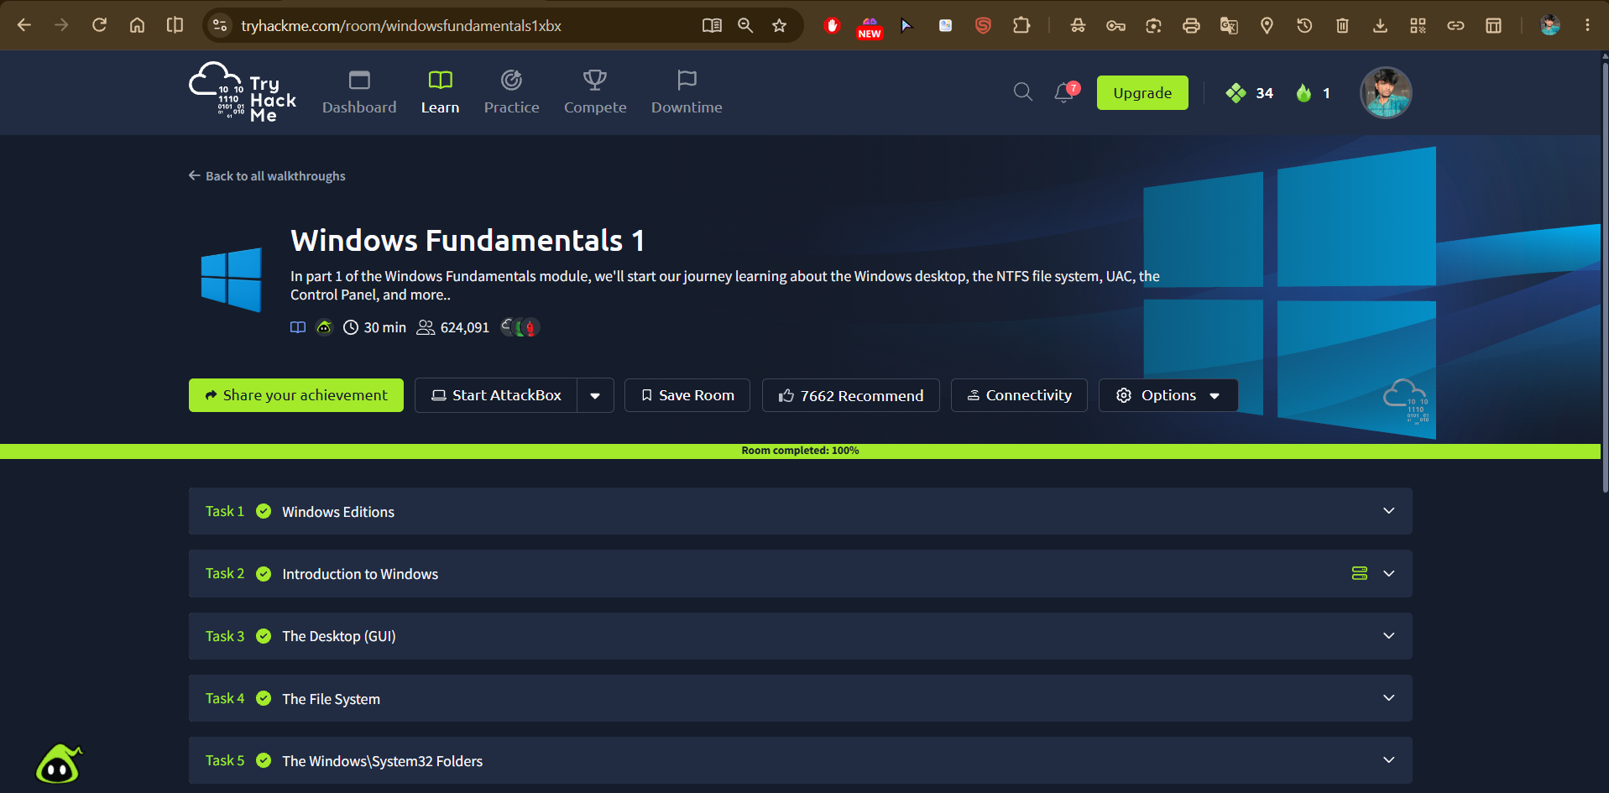Caption: Successfully completed Windows Fundamentals 1 and reviewed essential Windows system administration and security features.
7. Challenges Faced
The main learning challenge was understanding the purpose of different Windows administrative tools and how file permissions, User Account Control, and firewall settings contribute to system security.
8. Conclusion
This exercise strengthened my understanding of Windows fundamentals, system administration tools, file permissions, and built-in security features. These concepts provide a foundation for Windows event log analysis, endpoint monitoring, and security investigations as a SOC Analyst.

